Welcome to the 2020 EASI Conference
Acronyms/Terminology A to Z:
A/P – Accounts Payable
A/R – Accounts Receivable
API – Application Programming Interface, an interface or communication protocol between different parts of a computer program intended to simplify the implementation and maintenance of software.
ASN – Advanced Shipment Notice, Advanced Ship Notice, Advanced Shipping Notice, a notification of pending deliveries, an electronic packing list.
BOL – bill of lading, a document issued by the carrier to acknowledge receipt of a shipment to be delivered.
CO – Corrected -used in files when a corrected file is sent.
DUNS number- Data Universal Numbering System, a proprietary system developed and regulated by Dun & Bradstreet that assigns a unique numeric identifier, referred to as a "DUNS number" to a single business entity.
EASI - Embellished Activewear Standards Initiative (https://www.easistandards.com/)
EDI – Electronic Data Interchange, computer-to-computer exchange of business documents in a standard electronic format between business partners.
FDM4 – software solutions provider
FTP – File Transfer Protocol, a standard network protocol used for the transfer of computer files between a client and server on a computer network.
- FTPS is FTP with SSL (secure socket layers) for security.
- SFTP (SSH File Transfer Protocol/Secure File Transfer Protocol) was designed as an extension of SSH to provide file transfer capability, so it usually uses only the SSH (secure shell) port for both data and control.
GTIN - Global Trade Identification Number, an identifier for trade items, developed by GS1. They are used to look up product information in a database which may belong to a retailer, manufacturer, collector, researcher, or other entity.
For North American companies, the UPC (Universal Product Code) is an existing form of the GTIN.
Data structures of GTIN include:
- GTIN-12 (UPC-A): this is a 12-digit number used primarily in North America
- GTIN-8 (EAN/UCC-8): this is an 8-digit number used predominately outside of North America
- GTIN-13 (EAN/UCC-13): this is a 13-digit number used predominately outside of North America
- GTIN-14 (EAN/UCC-14 or ITF-14): this is a 14-digit number used to identify trade items at various packaging levels
PDD - Product Description Database, a SKU level item list with related SKU information.
PO – Purchase Order
POS – Point of Sale, daily sales and inventory levels at the item level
SSCC or SSCC18 - Serial Shipping Container Codes, establishes a consistent carton label with barcodes
SCAC - Standard Carrier Alpha Code, a code used to identify vessel operating common carriers (VOCC); typically, two to four letters long and were developed by The National Motor Freight Traffic Association.
SKU – stock keeping unit, an item number.
Trading Partner Relationship:
- Buyer – distributor - wholesaler – purchaser
- Supplier - vendor – mill – seller
UCC - Uniform Commercial Code
UOM – Unit of Measure, ea – each, dz, dozen
URL - Uniform Resource Locator, a web address
Notes:

Summary of Standards:
Export Import Relationship

832- PDD (Product Descriptor Database)
This file contains critical sku level data for each item including GTIN, weight, color, carton dimensions, carton case pack, etc.

856 – Advanced Shipment Notification
This file contains shipping information including tracking, products, units shipped, PO #, etc.

810 – Invoice
This file is a request for payment. It contains PO data, prices and terms.

846 – Inventory Status
This file contains inventory levels by supplier’s warehouse.

870 – Order Status
This file contains open PO number and items, along with the date the supplier expects each PO to ship.
821 – Account Statement
This file is used to reconcile outstanding invoices, credits and debits (vendor A/R and buyer A/P).

181 – Return Auth Response
This file is the supplier’s response to the buyer’s return authorization request (181).

IMG – Image Library
This file communicates different types of images available and is by GTIN.

Export Import Relationship

850 – Purchase Order
This file contains the shipping and billing instructions along with items and quantities being purchased.

861 – Inventory Advice Receipt
This file contains data related to previously received ASNs that are now physically part of buyer’s inventory.

180 – Return Auth Request
This file is a request by the buyer to the supplier to return goods.

852 – Point of Sale
This file contains the daily sales and inventory levels for each buyer warehouse. It is provided to the supplier.

940 – Drop Ship Purchase Order
This file contains purchase order information for orders to be shipped from the supplier to buyer’s customer.

867 – Monthly Resale Report
This file provides a summary of prior month sales information on the first of each month.

PLUL - Product Locator URL Link Standard
A standardized link to the buyer’s website on the supplier’s website.

Export Import Relationship

997 – Functional Acknowledgement
This file alerts the trading partner of a successful file receipt.

Routing Envelope
All transmitted EDI files are “wrapped” in an envelope – used to provide relevant information needed to transmit each file between trading partners.
Notes:

Key Data Elements:
Data Set | Code | Description | Notes
 | C | Conditional | Field is dependent on other fields and may or may not be filled.
 | O | Optional | Field is optional, filling preferred.
 | R | Required | Field must be filled.
Format | AN | Alpha-Numeric | Default: Include leading zero's
 | DT | Date | Default: CCYYMMDD
 | ID | Identification Code | Default: Include leading zero's
 | N | Number | Default: No leading zero's, no commas, no decimals
 | R | Real Number | Default: Real number including decimals
 | TM | Time | Default: HHMMSS (24-hour clock)
Field Size | # / # | Min/Max Length | First value is minimum length of field, second value is maximum.

Envelope – used to provide relevant information needed to transit each file between trading partners.
Compliance Matrix:
The compliance matrix contains trading partner compliance information; the who is on what version. The matrix is populated by technical committee throughout the year as updates are provided.
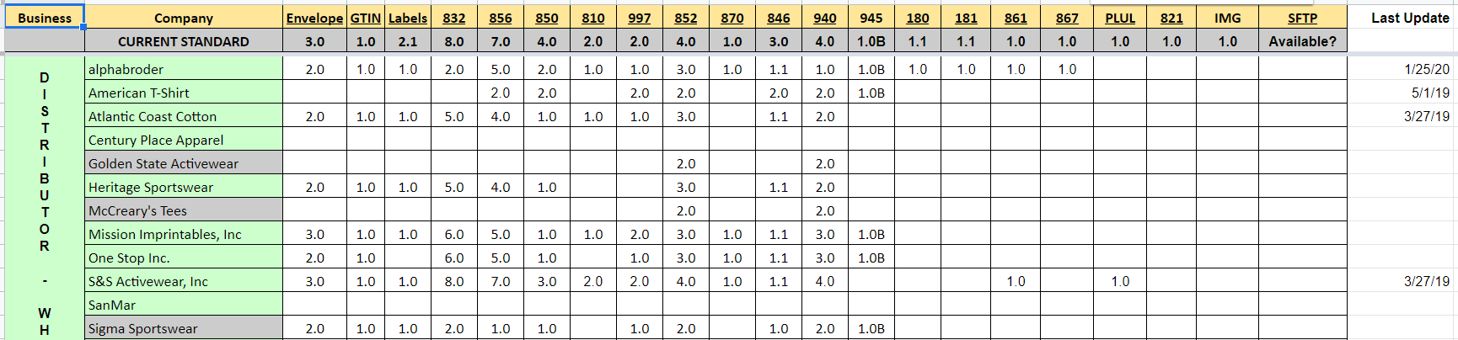
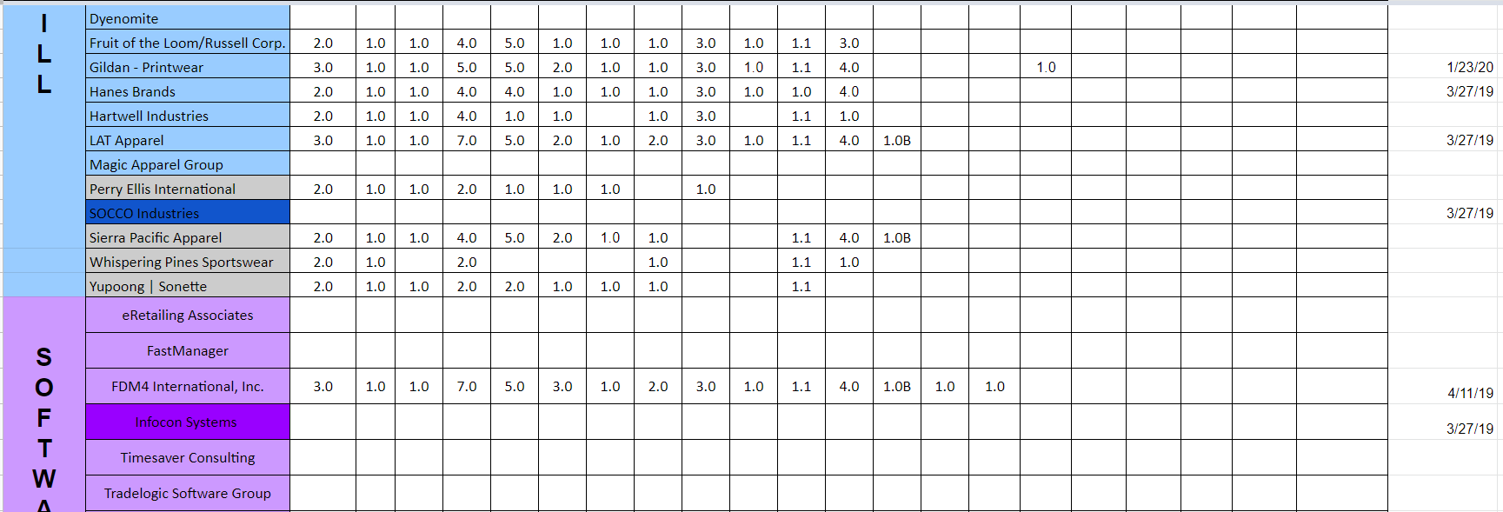
Please submit all compliance changes/updates to webmaster@easistandards.com.

